BIO542: Big Data Mining in Healthcare

(24th Feb 2024, Mid-Sem Exam)

Maximum Marks: 60 Duration: 75 Minutes

Instructions: This question paper have two sections, A and B. Attempt any 14 questions from section A, each question carries 2 marks (Total 28 marks). Attempt any 8 questions from section B, each question carries 4 marks (Total 32 marks). Write all answers in answer sheet only.

Section A
- Write name of two amino acids each encoded by six codons?
Arginine, Leucine, and Serine
- Graphically show, cutting of a DNA sequence by restriction enzyme.
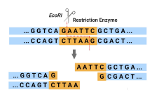
- Write name of three atoms which are building block of carbohydrates and lipids.
Carbon, Hydrogen, Oxygen
- Which name of database contain mendelian disorders? Write its year of establishment.
OMIM database contains mendelian disorders. It was established in 1960s.
- Write full form of TCIA and DICOM.
TCIA- The Cancer Imaging Archive
DICOM- Digital Imaging and Communications in Medicine
- Briefly describe embedded system and real time operating systems.
Embedded systems are the systems that are found within another system.
Real-time operating systems are designed for the information that needs to be updated in real time.
- Graphically show cloud computing.
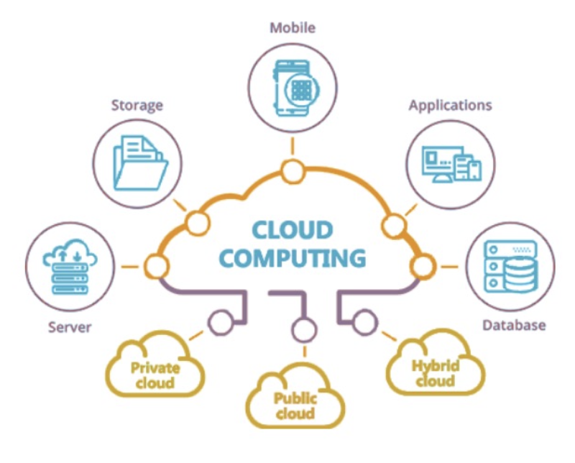
- In Python, if li = [‘ABC’, 4, 5, -4], what will be value of li[1] and li[-2] ?
The value of li[1] is 4, and the value of li[-2] is 5
- What is longitudinal data? briefly describe two longitudinal datasets.
Longitudinal data refers to information collected from the same subjects over a period of time.
Two longitudinal datasets –
- Tracking academic performance of students from elementary school to college, measuring grades at different time points.
- Tracking blood pressure of patients over multiple time points.
- Graphically show z-score based outlier detection; show outliers on graph.
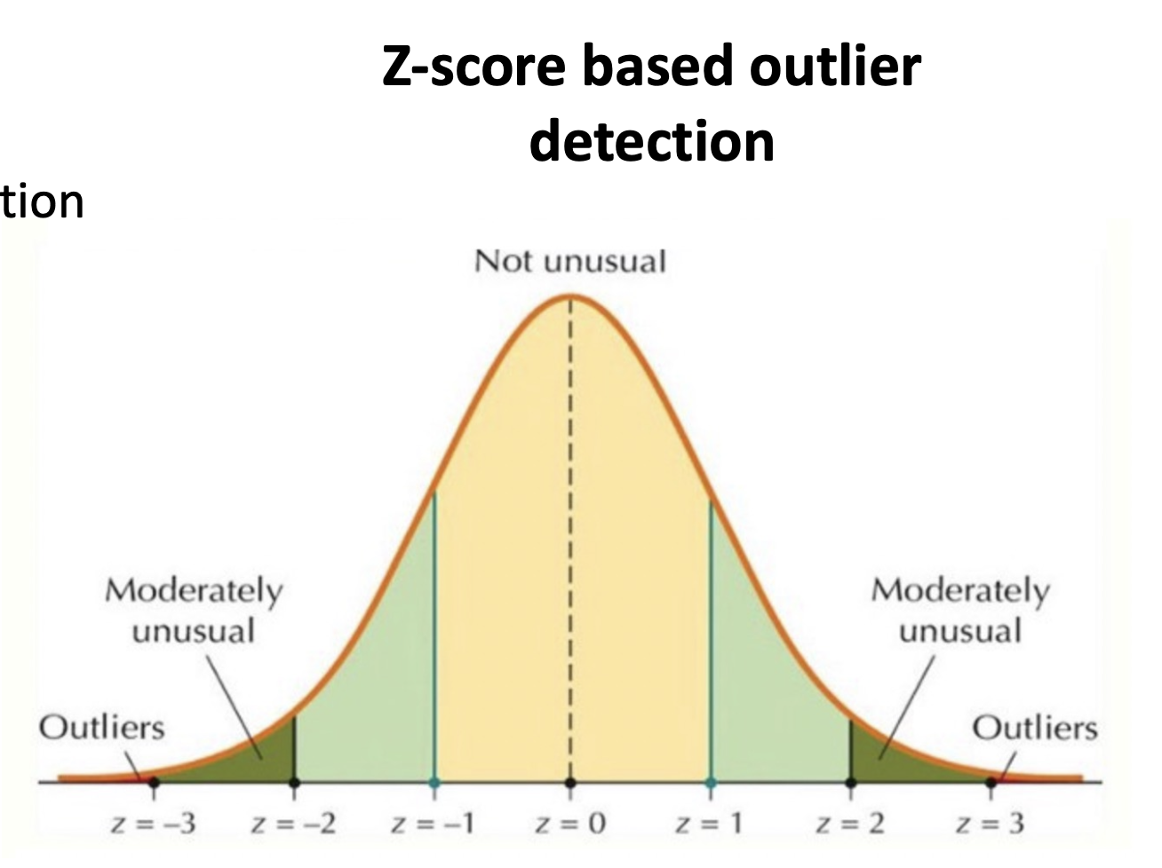
- If x = 0, what will be value of logit function f(x)?
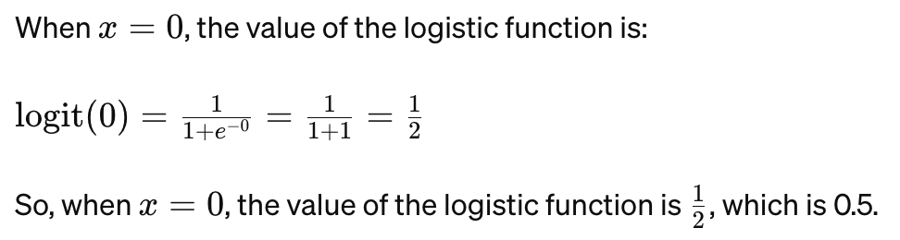
- Write formula for computing specificity and accuracy.
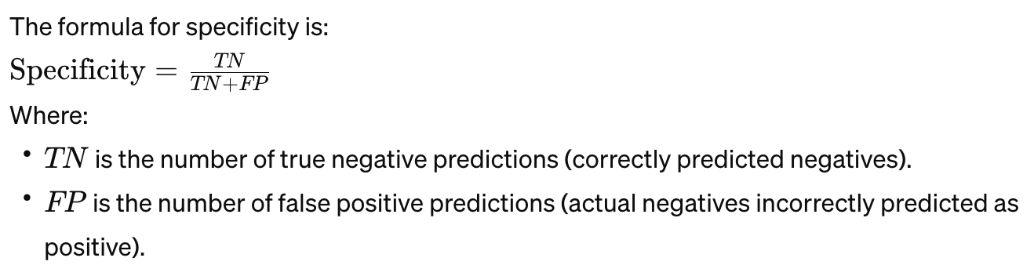
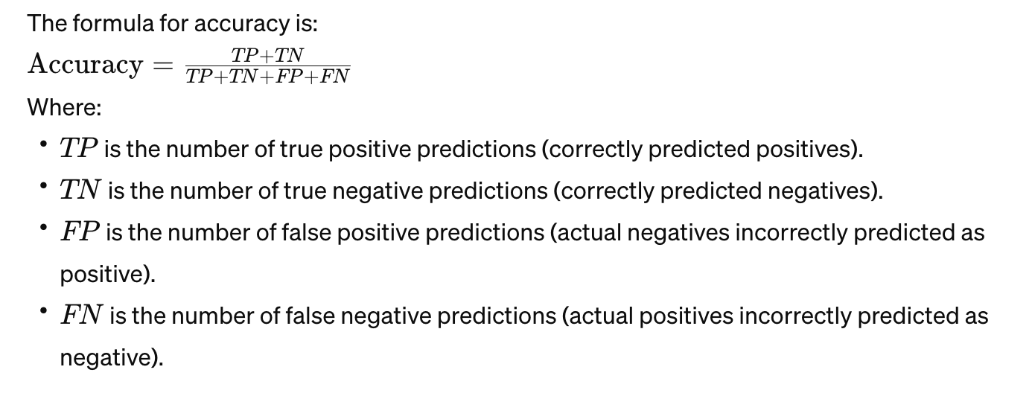
- Write name of four parameters used for evaluating regression methods
Mean Absolute Error (MAE), Mean Squared Error (MSE), Root Mean Squared Error (RMSE), R-squared (R2)
- Write full form of TF-IDF and its formula
Term Frequency-Inverse Document Frequency
Formula for TF-IDF = TF x IDF
Here,
TF(t,d) = Total number of terms in document d / Number of times term t appears in document d​
IDF = log [Nd/(1 + Nt)] , where Nd is total documents, Nt is number of documents contain term t
- What is full form of BASE in NoSQL.
Basically Available, Soft state, Eventually consistent
- Show one example document in MongoDB with five fields
{
"business_id": "rncjoVoEFUJGCUoC1JgnUA",
"full_address": "8466 W Peoria Ave\nSte 6\nPeoria, AZ 85345",
"open": true,
"categories": ["Accountants", "Professional Services", "Tax Services",],
"city": "Delhi",
}
- Calculate Manhattan distance between vector [5, 6, 9] and [9, 6, 5] 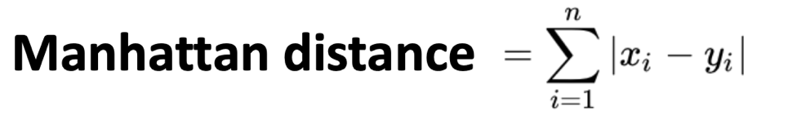
∣5−9∣+∣6−6∣+∣9−5∣
∣−4∣+∣0∣+∣4∣
4+0+4
8
So, the Manhattan distance between the vectors [5, 6, 9] and [9, 6, 5] is 8.
- Write name of two decision trees, used for searching in kNN
- k-D Trees (k-Dimensional trees)
- Quad Trees
- R-trees
Section B
- Draw a bacterial cell and labelled five major components of cell.
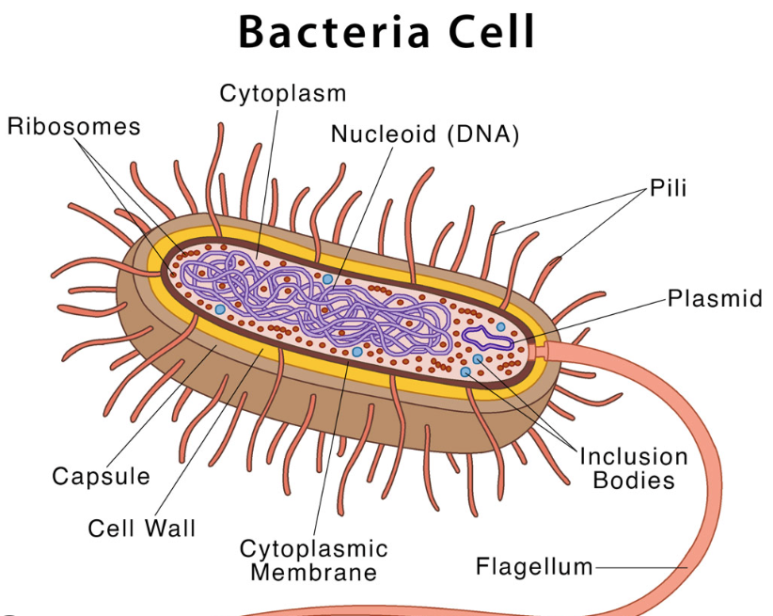
- Show by example, possible six open reading frames in a DNA sequence
An open reading frame (ORF) is a portion of a DNA or RNA sequence that has the potential to be translated into a protein. It starts with a start codon (usually ATG, which codes for the amino acid methionine) and ends with a stop codon (such as TAA, TAG, or TGA), without any other stop codons in between.

Consider a hypothetical sequence:

5’- AGTGAGTAAGTCGTCTTACGCTGGAGCTCTCATGGATCGGTTCGGTAGGGCTCGATCACATCGCTAGCCAT -3’

Frame +1: AGT GAG TAA GTC GTC TTA CGC TGG AGC TCT AGT GGA TCG GTT CGG TAG GGC TCG ATC ACA TCG CTA GCC AT
Frame +2: A GTG AGT AAG TCG TCT TAC GCT GGA GCT CTA GTG GAT CGG TTC GGT AGG GCT CGA TCA CAT CGC TAG CCA T
Frame +3: AG TGA GTA AGT CGT CTT ACG CTG GAG CTC TAG TGG ATC GGT TCG GTA GGG CTC GAT CAC ATC GCT AGC CAT

Reverse complement strand –
3’- ATGGCTAGCGATGTGATCGAGCCCTACCGAACCGATCCATGAGAGCTCCAGCGTAAGACGACTTACTCACT -5’

Frame -1: ATG GCT AGC GAT GTG ATC GAG CCC TAC CGA ACC GAT CCA TGA GAG CTC CAG CGT AAG ACG ACT TAC TCA CT
Frame -2: A TGG CTA GCG ATG TGA TCG AGC CCT ACC GAA CCG ATC CAT GAG AGC TCC AGC GTA AGA CGA CTT ACT CAC T
Frame -3: AT GGC TAG CGA TGT GAT CGA GCC CTA CCG AAC CGA TCC ATG AGA GCT CCA GCG TAA GAC GAC TTA CTC ACT

These are the possible six open reading frames in this DNA sequence.

- Describe PhysioNet including year of establishment, type of data and PhysioTookit.
PhysioNet: A unique web-based resource funded by NIH, intended to support current research and stimulate new investigations in the study of complex biomedical and physiologic signals.
It was established in 1999, September.
Type of Data - Large collections of recorded Physiologic Signals.
PhysioToolkit: Open-source software for physiologic signal processing and analysis:
- Detection of physiologically significant events using both classical techniques and novel methods
- Interactive display & characterization of signals; creation of new databases
- Physiologic signal modelling and for quantitative evaluation and comparison of analysis methods.
- Review paper on healthcare have been organized in five topics; write name of each topic.
1. Drug discovery 2. Toxicity and adverse effects 3. Vaccine Development 4. Disease biomarkers 5. Healthcare to IoTs
- In Python, write commands to open a file, read whole file and read N bytes in a string.
Open a file - input = open(‘data’, ‘r’)
Read whole file - S = input.read()
Read N bytes - S = input.read(N)
- In python using sklearn write code for calculating accuracy and AUC.
from sklearn import metrics
Accuracy = metrics.accuracy_score(y_test, pred)
AUC = metrics.roc_auc_score(y_test, pred)
- Graphically show maximum margin classification in SVM with Slack variables.
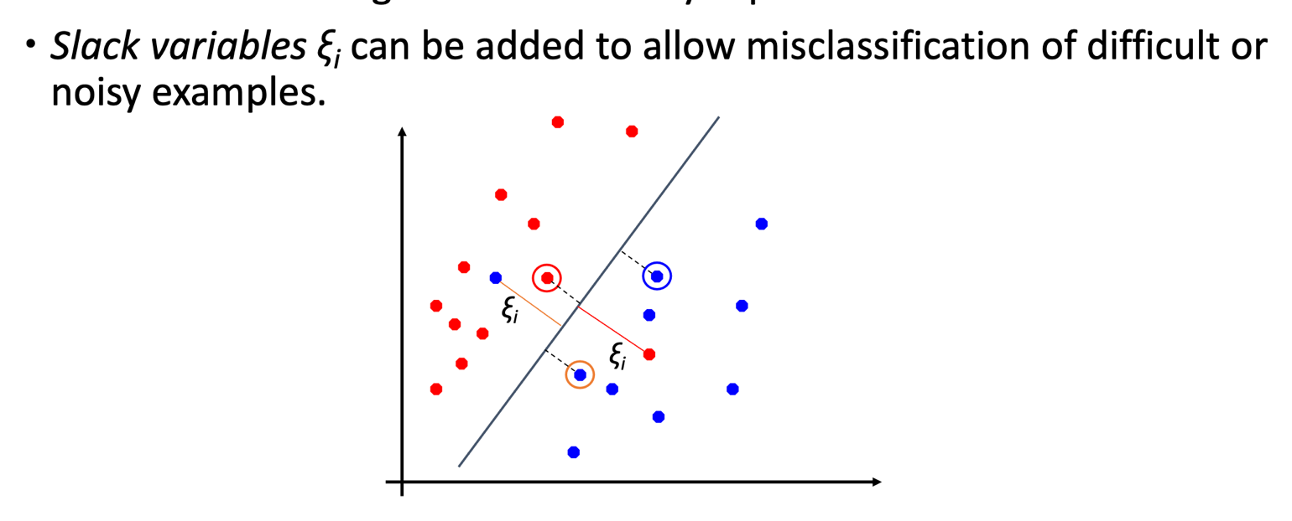
- Show graphically traditional dipeptides and higher order dipeptides in a protein sequence
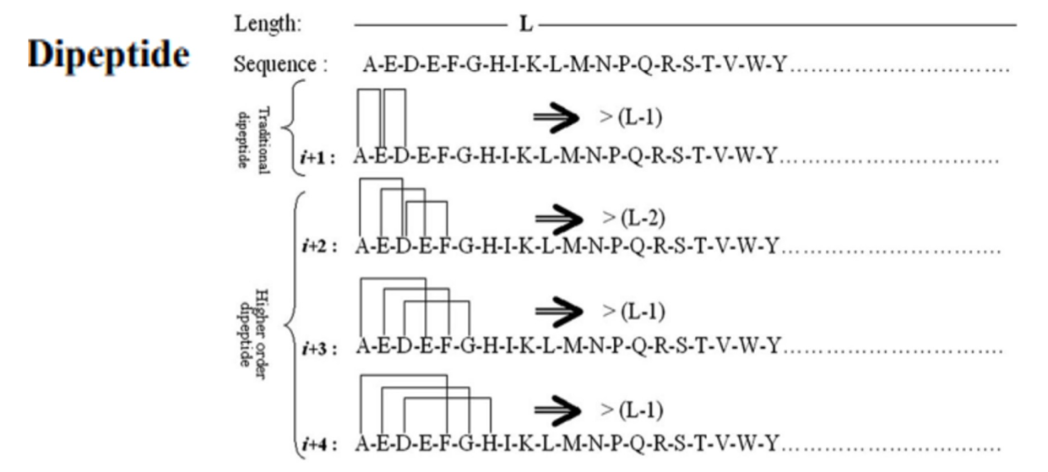
- Show MapReduce by example, label map and reduce.
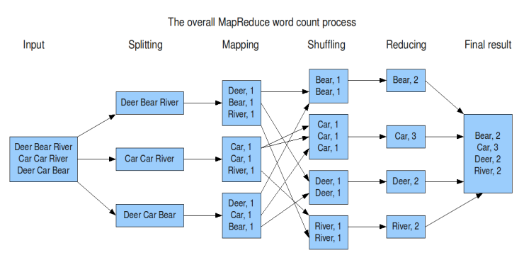
- Show objective function vs iteration step by linear graph for GD and SGD
